**Exp.6: Preparation of Nitrobenzene**

**Aim of experiment: Nitration of benzene Example on (electrophilic**

**aromatic substitution)**

**Nitrobenzene** was first prepared in *1834* by the German chemist *Eilhardt*

*Mitscherlich*. Nitrobenzene, the simplest aromatic nitro compound, have the

molecular formula C6H5NO2.

It is used in the manufacture of aniline, benzidine, and other organic chemicals.

Nitrobenzene is a colorless to pale yellow, oily, highly toxic liquid with the odor

of bitter almonds.

Other names: Nitrobenzol and Oil of mirbane.

**Solubility**

**1-** very slight to insoluble in water.

**2-** Slightly soluble in carbon tetrachloride.

**3-** Soluble in ethanol and acetone.

**4-** Completely Miscible with diethyl ether and benzene.

**Uses of nitrobenzene**

**1-** Approximately 95% of nitrobenzene is used to produce aniline.

**2-** Production of acetaminophen (paracetamol).

**3-** Perfume for soaps due to its low cost.

**4-** Production of benzidine.

**5-** Nitrobenzene is also used to produce lubricating oils and in the

manufacture of dyes, drugs, pesticides, and synthetic rubber.

**Electrophilic Aromatic Substitution (EAS)**

Although aromatic compounds have multiple double bonds, these compounds do

not undergo addition reactions. Their lack of reactivity toward addition reactions

is due to the great stability of the ring systems that result from complete π electron

delocalization (resonance).

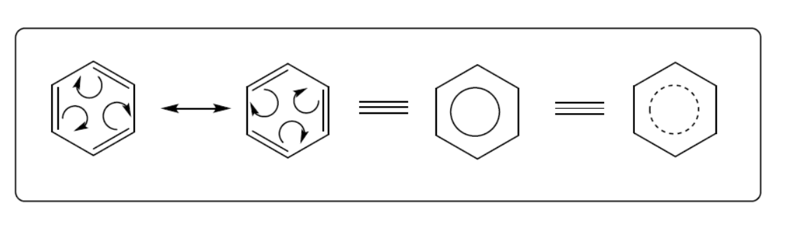

Aromatic compounds react by electrophilic aromatic substitution reactions, in

which the aromaticity of the ring system is preserved.

A key reaction of aromatic compounds is electrophilic aromatic substitution,

where a C-H bond is broken and a new C-E bond is formed. **(E being an**

**electrophilic atom such as Cl, Br, N…)**



**Procedure**

1) 7 ml of conc. HNO3 is added to a round bottom flask, add 8ml of conc.

H2SO4 with continuous stirring, this process must be done in an ice bath.

2) Add 6 ml of benzene drop wise to the mixture, below 50 oC in all times.

3) After all benzene added, the solution is pale to yellow color and heated to

near 55-60 oC (the temperature must not reach more than 60 oC) with

continuous stirring for nearly one hour.

4) After one hour, the solution left to cool and the two immiscible layers are

simply distinguished.

5) Separation funnel is used to separate the two immiscible layers from each

other.

6) The lower layer is acids and the upper layer is the nitrobenzene. Which can

be purified and yield percent can be found.

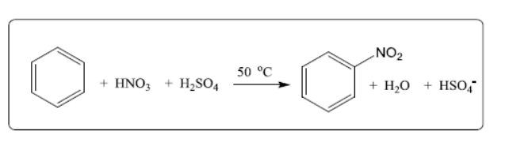

**Note**

* Benzene is treated with a mixture of concentrated nitric acid and

concentrated sulphuric acid at a temperature not exceeding 50°C. As

temperature increases there is a greater chance of getting more than one

nitro group, -NO2, substituted onto the ring.

* Sulfuric acid acts as a catalyst.