**EXP. 2: Recrystallization of salicylic acid**

**Aim of experiment: purification of the synthesized salicylic acid**

**Procedure:**

1- Put 1 g of impure Salicylic acid sample in a beaker.

2- Try to dissolve it in a minimum amount of hot water with heating.

3- Filter the solution while it is hot, all the equipments should be kept hot during the first filtration, (Hot filtration).

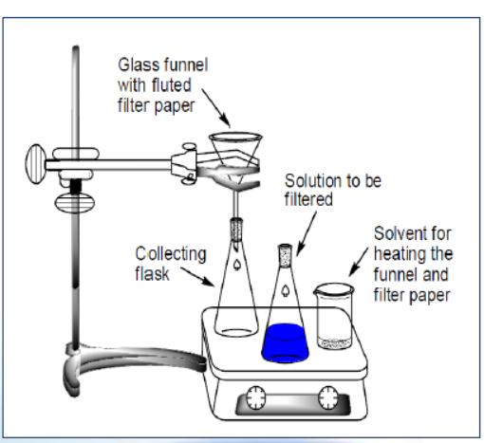

4- Cool the filtrate, then Salicylic acid will crystallize.

5- Filter again, (*Cold filtration*).

6- Collect the crystals of S.A. on the filter paper and

dry them on oven.

The resulting solid after drying is tested for purity usually by melting point determination, spectroscopic method or TLC.

If it's found impure it should be recrystallized again from fresh solvent.