EXP. 3: Preparation of Acetylsalicylic acid

**Aim of experiment: *Preparation of Aspirin.***

## Properties of Acetylsalicylic acid, Aspirin.

1. Aspirin occurs as white crystals or as a white crystalline powder.
2. It is slightly soluble in water (1:300), soluble in alcohol (1:5), chloroform (1:17) & ether (1:15). It dissolves easily in glycerin.
3. Practically all salts of aspirin (soluble in aqueous media) , except those of aluminum and calcium (insoluble in aqueous media), are unstable for pharmaceutical use.

Aspirin gives No color with FeCl3 solution.

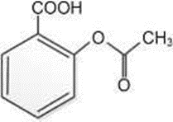

1. It's used as antipyretic, analgesic & antirheumatic in tablets, suppositories, vials, …etc. dosage form.
2. Aspirin is stable in dry air, but in the presence of moisture, it slowly hydrolyzes into acetic acid and salicylic acid.

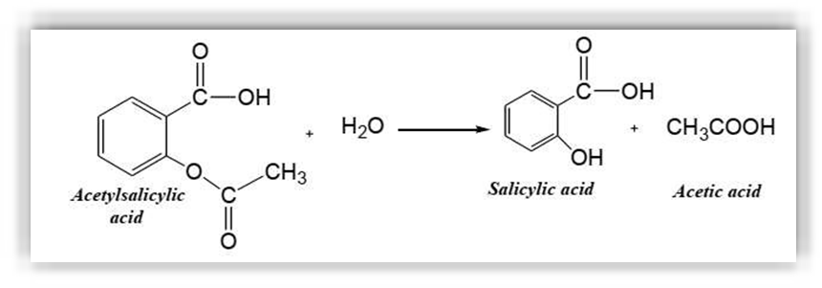

* + So old aspirin tablets may have a smell like vinegar as a result of the hydrolysis reaction that produces acetic acid (Ethanoic acid).

## Procedure:

1. Put 2.5 gm of S.A in a dry conical flask.
2. Add 5 ml of acetic anhydride.
3. Shake well.
4. Add 3-5 drops conc. H2SO4 .
5. Warm on water bath to (50-60) oC for about (10-15) min.
6. Stirring, cooling (ppt. of aspirin ) then add 75 ml D.W .
7. Filtration, wash the ppt. with cold D.W. and collect the product (aspirin).

# Equation:

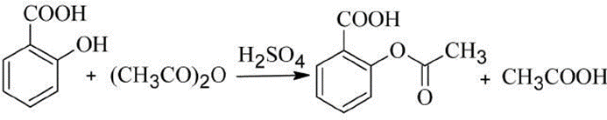

Notes:

* + The conical flask should be dried well since the presence of moisture could hydrolyze acetic anhydride to acetic acid.

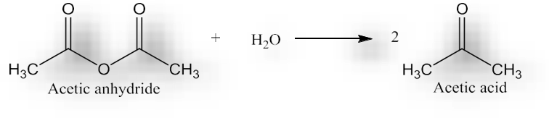

* + The 1st step in this esterification is to create a suspension of Salicylic acid (a solid at r.t.) in an excess of Acetic anhydride (a liquid at r.t.).
  + So, Acetic anhydride serves as both a reactant and a solvent.
  + A catalyst is required for this reaction. Conc. H2SO4, donates a proton which binds to the reaction complex.
  + As a catalyst, H+ is regenerated, not consumed by the end of the reaction. As the reaction proceeds, the solid S.A. disappears and the Acetylsalicylic acid product remains dissolved in the hot solution.
  + Once all solid has disappeared (all the S.A. has been consumed) the reaction is completed.
  + Avoid very high temperature or prolonged heating period since the synthesized acetylsalicylic acid may decompose.

At this point the *excess unreacted* Acetic anhydride must be hydrolyzed (split apart by the addition of water) to acetic acid. Acetic anhydride is very reactive toward water, so the hydrolysis must be done slowly, water should be added drop-wisely. More water is then added and the flask is placed in an ice bath to lower the solubility and precipitate the prepared aspirin.

* + The collected ASA is then recrystallized by using mixed solvents to further purify the product.

# Tests on Aspirin:

1. Test with Bicarbonate Acetylsalicylic acid molecules still contain the organic acid group (carboxyl) and will react with sodium bicarbonate to release carbon dioxide gas:

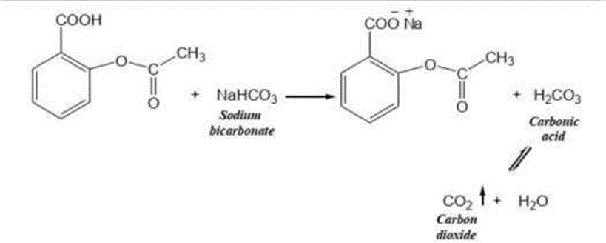

Add a very small portion of your aspirin (crude or purified) to a test tube. Add also a small portion of sodium bicarbonate. Add a small amount of water and note the evolution of carbon dioxide. This test indicates only that aspirin is an acid; **it is not a specific test for aspirin**.

1. Test with Iron (III)

Set up three test tubes in a rack. To the first test tube, add a small quantity of pure salicylic acid as a control. To the second test tubes, add very small portions of your crude and purified aspirin. To the third test tube, add 1ml of aspirin solution. Add 8-10 drops of iron(III) chloride (ferric chloride) solution to each test tubes. The appearance of a pink or purple color in your aspirin of the commercial table sample indicates the presence of salicylic acid.