**Fourth stage- Al-Zahraa university- college of pharmacy**

**EXP. 1: Alkaline hydrolysis of Ester**

**Aim of Experiment: -Preparation of Salicylic acid by hydrolysis of methyl salicylate**

**Theory**

Salicylic acid (S.A.) is a phenolic acid, it has di-functional groups on the benzene ring, an-OH group, and a-COOH group. Salicylic acid and its derivatives are widely used in the synthesis of pharmaceutical products, it has strong antiseptic and germicidal properties; therefore, it’s used as a preservative material for foods and pharmaceuticals. In addition, it has good treatment for warts, corns, and athlete’s feet. it shows good anti-inflammatory, antipyretic, and analgesic activities, its salts and derivatives are used for these purposes. Salicylic acid can be used as an intermediate in the synthesis of dyes and agrochemical and perfumery products.

The derivatives of salicylic acid can be divided into two types depending on the attack on which group takes place

**Type (1):** - Represent the modifying of carboxyl-group of salicylic acid (salts, esters or amide)

**Type (2)**: - Substitution on phenolic group of salicylic acid

***Chemical Structures***

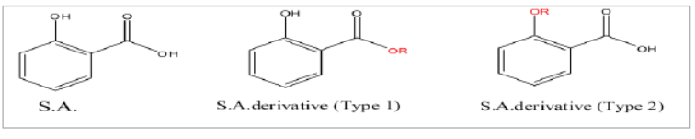

***Preparation Method of Salicylic acid***

An ester can be hydrolyzed by an aqueous base (Saponification) or via aqueous acid to yield a carboxylic acid plus alcohol, as following:

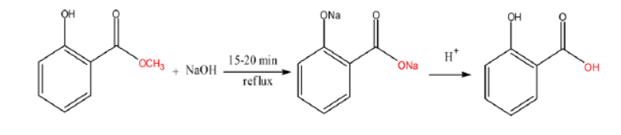

**Mechanism of Base-catalyzed ester hydrolysis**

Step (1)**:**- The nucleophilic (-OH) ion adds to the ester carbonyl group, forming tetra-hedral alkoxide intermediate.

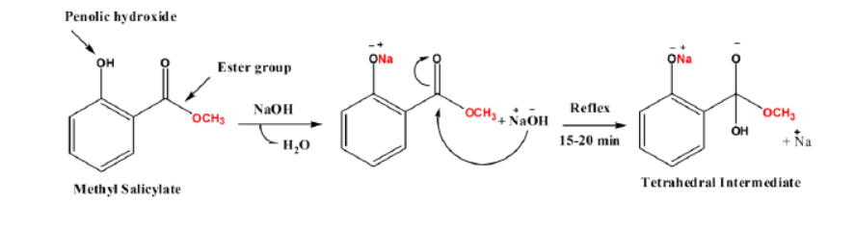

Step (2):- Elimination of methoxide group to generation the carboxylic acid.

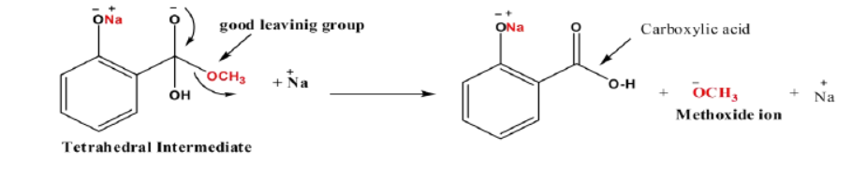

Step (3):- Methoxide ion abstracts the acidic proton from carboxylic acid group to formation a carboxylate ion plus alcohol.

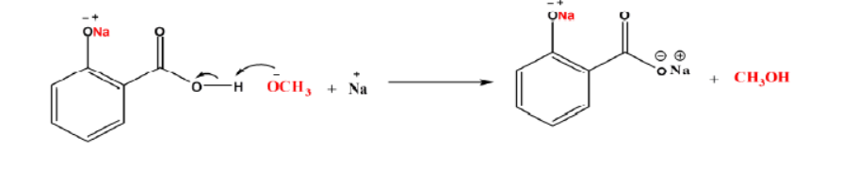

Step (4):- Protonation of the carboxylate ion via the addition of aqueous mineral acid in a separate step to yield carboxylic acid.

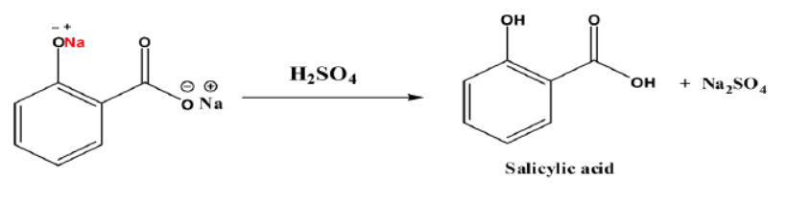

**Preparation method**

1. put 5gm from methylsalicylate in 250ml boiling flask
2. Add 50 ml of 20% (w/v) aq. NaOH solution and mix, at this point, can observe the formation of white ppt. (sodium salt of methyl salicylate phenolic group) but will re-dissolve again on heating
3. Reflux the mixture at the boiling point for 15-20 min.
4. Transfer the mixture to a 125 ml beaker, cool and acidify with H2SO4 (check acidification by litmus. paper).
5. Further cooling is required, then filter and collect the ppt.
6. Recrystallized salicylic acid from minimum amount of hot water.

**Chemical properties of salicylic acid**

Common name: Salicylic Acid

Odor: Odorless

IUPAC Name: 2-hydroxy benzoic acid

Taste: Acrid

Molecular Formula: C7H6O3

Melting point: 158oC

Molecular Weight: 138.12gm/mol

Density: 1.44gm/cm3

Appearance: Colorless to white crystals

**Calculations:**

**Percentage practical yield** = Practical yield / Theoretical yield X 100

The theoretical yield can be calculated via the equation under theory as stated under

152 gm from methyl salicylate on reacting with 40 gm of Sodium Hydroxide yields 138 gm Salicylic acid

5 gm from methyl salicylate shall yield Salicylic acid = 152/138.12X5 =4.5gm

Therefore, Theoretical yield of Salicylic acid = 4.5gm

Practical yield = X